**BugFest 2023!**

**The Crosby Arboretum**

**370 Ridge Road**

**Picayune, MS 39466**

**601-799-2311**

Here are programs already registered for BugFest as of August 12, 2023

**Event Dates: Friday, October 13th and Saturday, October 14th**

Audubon Butterfly Garden and Insectarium

Native & exotic arthropods (some are touchable), preserved specimens

Mandy Sartain’s Bat Booth – MSU Extension – Friday 9:30 to 12:30 booth

Dr. Eddie Smith – Pearl River County Coordinator & Extension Agent IV

Steve Barney, the “Beetle Man” from Louisiana,

over 25 yrs of experience with Beetles, (Saturday booth from 10 AM to 2 PM)

Dr. Blair Sampson, Research Entomologist, will host a booth featuring Bees & Pollinators along with Amy (horticulturist), Austin (Entomologist),

and Chris (Entomologist) – Friday from 9:30 am to 12:30 pm

The Hattiesburg Zoo – Saturday booth from 10 AM to 1 PM

(The zoo will be bringing Carl and Carla – hissing cockroaches from Madagascar, a tarantula, and 1 or 2 animals that eat insects)

Linda Auld – NOLA Bug Lady, Butterflies & Caterpillars, Saturday from 10 am to 2 pm

Patrick Allison’s Crayfish Booth – both days – Keep your eye out for the BIG crayfish!

Breanna Lyle and her Tarantula!

Dr. Jeff Harris - Exhibit Friday and Saturday

Dept of Biochemistry, Molecular Biology, Entomology, and Plant Pathology

Photo competition featuring Arthropods – open to all ages - no registration fee!

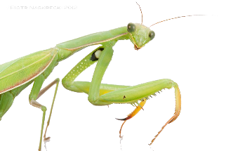<http://msuext.ms/23bugfest>

BugFest Midway with Games and Crafts

Dancing Praying Mantises

And more!

Our Art Gallery will feature arthropod photographs from

Sept. 1st through the end of November.

View photographs of arthropods taken by Robert Smith (Mississippi Wildlife), Donna Bush (Slidell Magazine), and Dr. Blair Sampson (Research Entomologist with USDA-ARS Southern Horticultural Research Laboratory).

