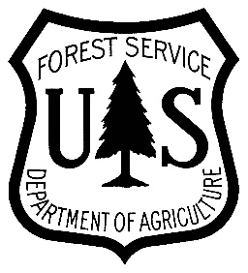
Now Recruiting
Volunteer
Volunteers
De Soto National Forest
Celebrating 50 Years Wild & Scenic Rivers

Lend a Hand! Care for the Land!
The De Soto Ranger District is looking for dedicated people.

Nature needs YOU!
Please join us and help care for our precious resource.

- Pick any date throughout the year

- Volunteer opportunities:
- Trail Maintenance – hiking, OHV, motorcycle, mountain bike or horse
(Adopt a section on your favorite trail.)
- Campground maintenance – your favorite site or general cleanup
- Forest cleanup - roads, trails or rivers (Forest maps or canoe rentals available.)
- Archaeology – Fishing Derby – Other (Please let us know.)

- Register your group or individual
For more information and to volunteer contact:
Marilyn Stone 601 528-6160 ext. 0
Email: msstone@fs.fed.us
