Volunteer Program

Assist Audubon Delta staff in Mississippi with monitoring and protection of beach-nesting birds!
Volunteers Needed For:
- Setting up symbolic fencing
- Resighting banded birds
- Colony stewardship
- Assistance on island trips
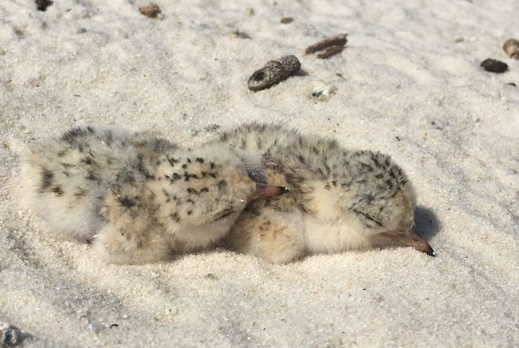

Volunteers are needed year round, especially from mid-April through mid-August, mostly in mornings and early afternoons.
Volunteers will gain experience in:
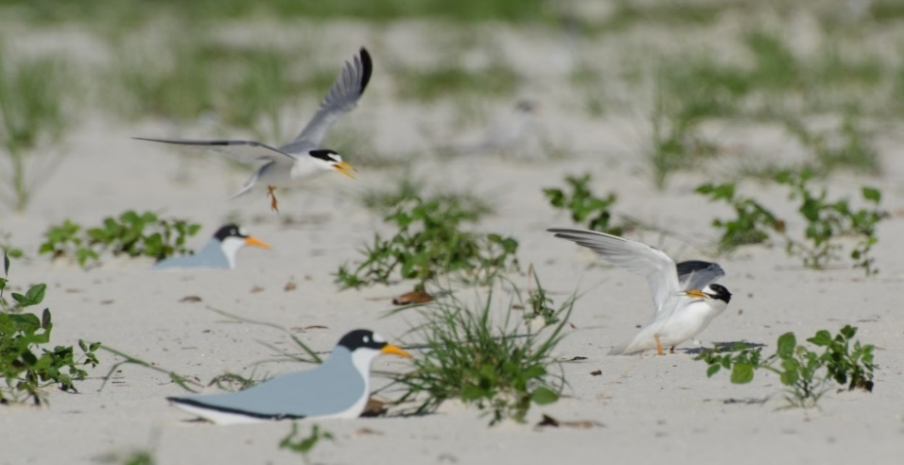
- Applied conservation biology
- Scientific data collection
- Coastal bird ecology
- Public outreach
Gain Conservation Experience!
Island Visits!

Interested? Email Tim Guida at Tim.Guida@audubon.org
Website: ms.audubon.org Find us on Facebook! (Audubon Mississippi Coastal Bird Stewardship Program)

